Lab 5 Pseudocode

7.9 (smallest element)

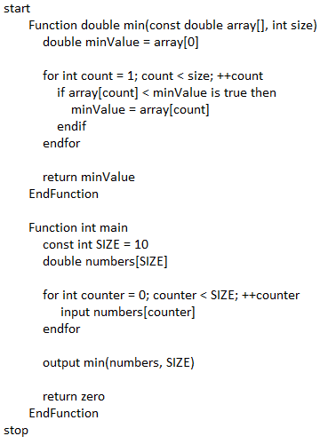

7.23 (identical arrays)

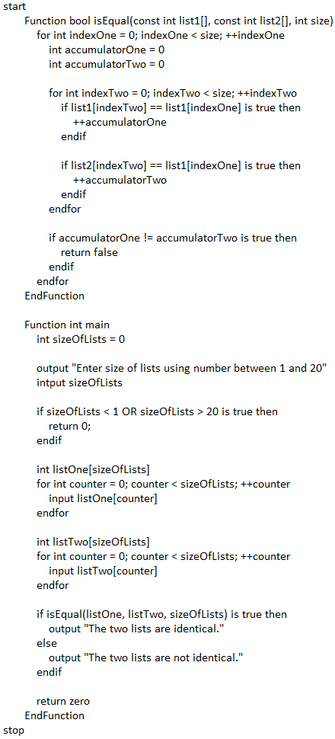

7.25 (count of sums of 24)

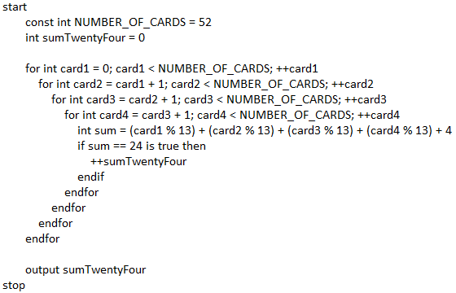

7.37 (occurrence of letters)

